**How to Generate API Keys from ByBit**

**Introduction** In order to enhance the functionality of your Bybit account facilitate secure communication with external applications, you can create API keys.

In this document, we will explore how you can generate API from ByBit.

Let’s get started

**Steps 1: Access account** Go to your account setting by clicking the **human icon** on your trading page, then select “**API management”**.



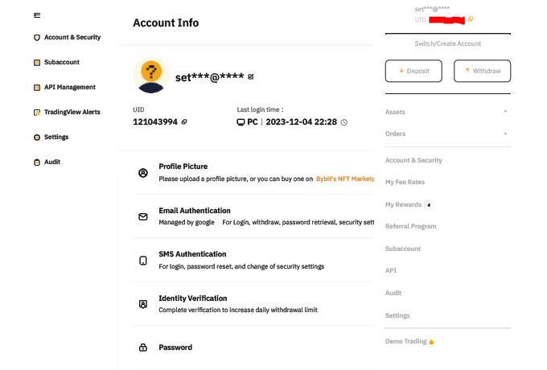

**Step 2: Create New Key** on the **API Management page**, click **“Create New Key”** on the right.

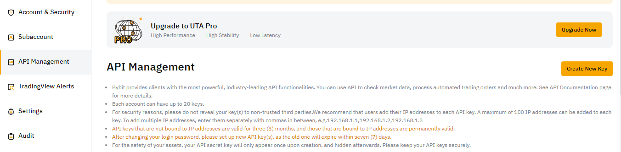

**Step 3: Security Verification.**

3.1 In the pop-out window, click set up and then click “**Google 2FA Authentication**”. 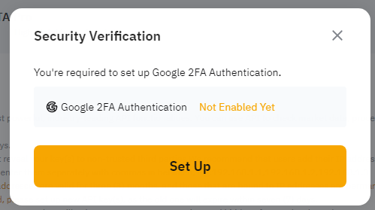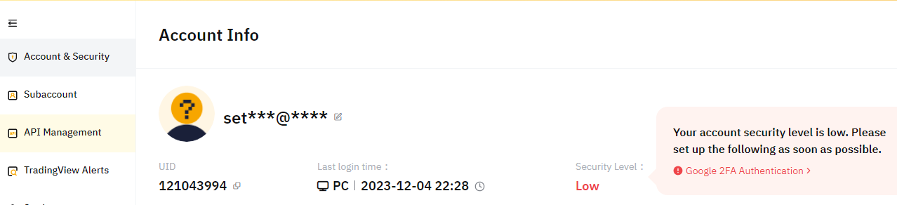

3.2 Enter your verification code, click “**confirm**”.

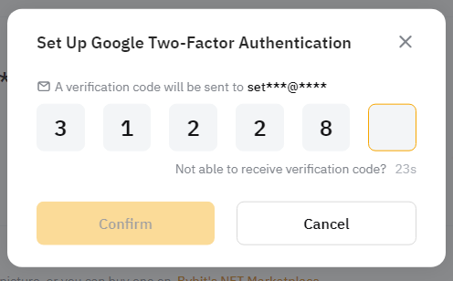

3.3 Download Google Authenticator Android / iOS

Google Authenticator can be downloaded from the App store or Google Play.

Search “Google Authenticator” and proceed to download.

3.4 Add key phrase into Google Authenticator and remember the key phrase

Open Google Authenticator, scan the QR code below or manually enter the key phrase to activate the verification token

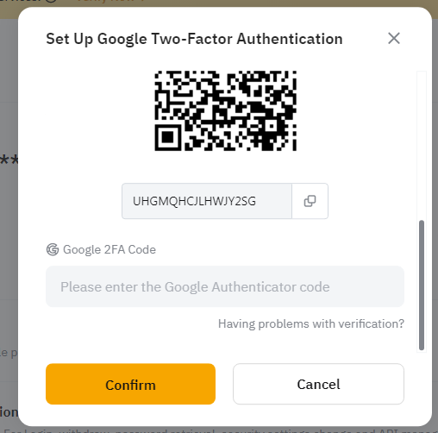

**Step 4: Configure and confirm** 4.1In the pop-out window, click **‘’System-generated API Keys” and ‘’Self-generated API Keys”**.

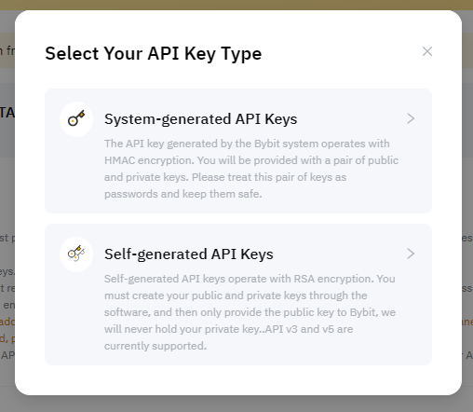

4.2 In the pop-out window, fill the all required details, and click **“Submit”.**

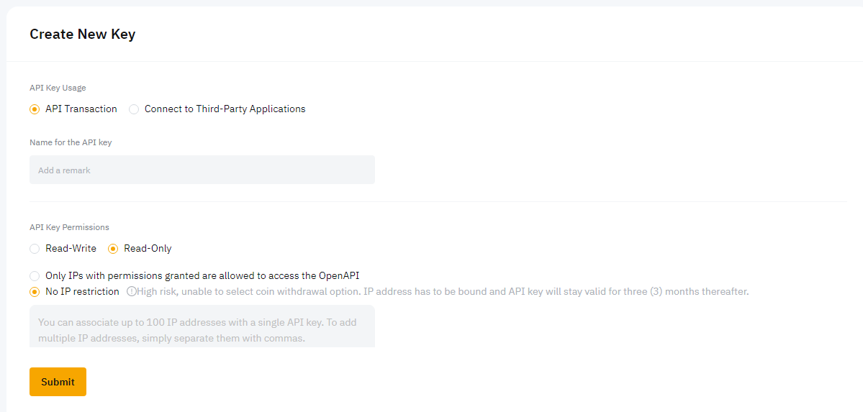

Congratulation! You have successfully generate API key.

**NOTES**

1. The creation API can only be done via PC/website, there is no option to do it via Bybit APP.
2. Keep it secure and avoid sharing your secret.
3. Regularly review and update your API settings
4. Ignore step 3 if you have account already.